**Live Project-Internship Report**

on

Current Business Scenario in Vietnam

By

**Akshat Yadav**

a student at Shri Ram College of Commerce,

Global Business Operations

Roll No: 23GB069

Under the Guidance of

Industrial Mentor: Navneet Kumar

(Head of Strategic Planning)

Submitted to

**VE Commercial Vehicles**

September 2023

**Acknowledgement**

I am deeply grateful to **Mr Navneet Kumar**, my mentor and advisor during this internship-project, for their invaluable advice and guidance. Their industry experience and expertise helped me to better understand the company and the industry, and allowed me to make the most of my internship.

Throughout the project, Navneet Sir provided me with valuable insights and guidance that helped me to navigate my tasks and responsibilities. They were always available to answer my questions and provide support, and their wisdom and expertise helped me to grow as a professional. I am thankful for their time and support, and for sharing their valuable insights with me.

**Table of Contents**

Introduction 4

Country Profile: Vietnam 5

Current State of Economy 8

Vietnam’s Commercial Vehicle Market 10

Vietnam Electric Vehicle Market 19

Vietnam Commercial Vehicle Lubricants Market 26

Volvo in Vietnam 29

The forthcoming lineup of Volvo cars in Vietnam 36

The Modern Vietnamese Consumer 37

Bibliography 38

# Introduction

The purpose of this extensive report is to provide a comprehensive overview of the commercial vehicle market in Vietnam. The report offers crucial insights into the current state and outlook of this rapidly evolving industry by analysing key segments, trends, policies, major players, challenges, and opportunities.

The scope of the report encompasses both domestic and foreign commercial vehicles operating in Vietnam across all weight segments. It examines various vehicle categories including trucks, buses, vans, and specialized vehicles used for logistics, public transportation, construction, agriculture etc. Trends in electrification, sustainability, safety, and connectivity shaping the global commercial vehicle landscape are also explored in the Vietnam context.

Macroeconomic factors like GDP growth, infrastructure development and industrialization along with regulatory policies and incentives driving Vietnam's commercial vehicle market are highlighted. The report studies leading OEMs and evaluates the competitive landscape while assessing growth strategies. Trade dynamics in the form of import-export statistics are provided and lubricants demand is quantified.

Consumer behaviour patterns influencing commercial vehicle purchase decisions are analysed. The outlook for Vietnam's electric and autonomous commercial vehicle market is projected based on current adoption rates and government policy support. Overall, the report serves as a guide for stakeholders to navigate opportunities and challenges in Vietnam's fast-evolving commercial vehicle industry.

# **Country Profile: Vietnam**

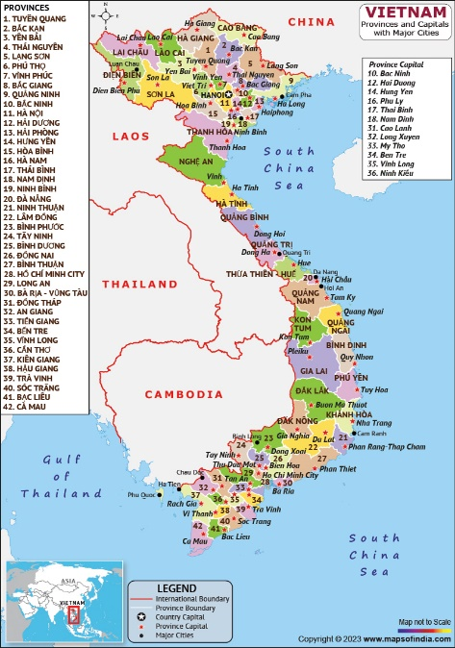Before delving into the specifics of Commercial Vehicle (CV) market in Vietnam, it is essential to establish a foundational understanding of the country itself. Vietnam, situated in Southeast Asia, is a nation characterized by its rich history, diverse geography, dynamic economy, and a population marked by cultural diversity. In this section, we will provide a comprehensive country profile that encompasses Vietnam's geographical features, demographics, political and economic landscape.

**Geography**

|  |  |
| --- | --- |
| Land area | 331,210 sq. km |
| Coastline length | 3,260 km |
| Major rivers | Red River, Mekong River |
| Climate | Tropical, Monsoon |

**Demographics**

|  |  |
| --- | --- |
| Population | 100.35 million (2023) |
| Population growth rate | 0.8% |
| Life expectancy | 69.12 years male,  78.24 years female (2021) |
| Urbanization rate | 41.7% (2022) |

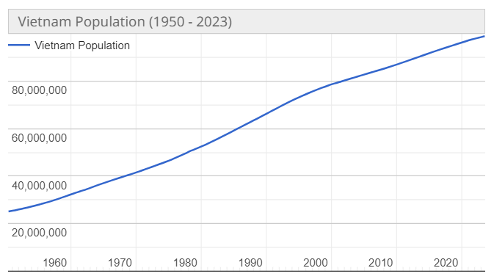

**Political Landscape**

Vietnam is a socialist republic with a single-party system, where the Communist Party of Vietnam (CPV) is the only legal political party. The CPV holds significant influence over all aspects of the government, and its General Secretary is considered one of the most powerful figures in the country.

**Political Structure**: Vietnam's political structure consists of three main branches: the Executive (headed by the President), the Legislative (National Assembly), and the Judicial. The President serves as the Head of State, while the Prime Minister is the Head of Government.

**Elections**: Elections are held periodically, and the National Assembly is the highest representative body, responsible for passing laws and policies. However, it's important to note that all candidates in elections must be approved by the CPV, leading to limited political pluralism.

**Recent Political Developments**:

As of 2023, Vietnam is led by a three-person collective leadership. The key figures in this leadership structure include:

President *Vo Van Thuong* (since 2023): As the head of state, President Vo Van Thuong plays a prominent role in representing Vietnam internationally and overseeing ceremonial duties.

Prime Minister *Pham Minh Chinh* (since 2021): Prime Minister Pham Minh Chinh serves as the head of the government, responsible for the administration and implementation of policies and programs.

*Nguyen Phu Trong* (since 2011): Nguyen Phu Trong holds the powerful position of General Secretary of the Communist Party of Vietnam (CPV). He wields significant influence over the country's political landscape and policy decisions.

**Economy**

|  |  |
| --- | --- |
| GDP | $449.09 billion (2023) |
| Real GDP growth rate | 3.9% (2023) |
| GDP per capita | $6670 (2023) |
| Imports | $358.9 billion (2022) |
| Exports | $371.85 billion (2022) |
| FDI inflow | $17.9 billion (2022) |

In 2022, the service sector played a pivotal role in Vietnam's gross domestic product (GDP), constituting the largest share at 41.8 percent. This sector encompasses the production of intangible goods for both businesses and end consumers. Approximately 37.48 percent of Vietnam's population is employed in the service sector.

Vietnam boasts a youthful and productive workforce, with around 69 percent of its 100 million residents falling within the working-age bracket of 15 to 64 years. The country maintains a low unemployment rate of approximately 1.8 percent and is regarded as a significant regional economic powerhouse, consistently achieving an annual economic growth rate ranging between 6 and 7 percent.

Vietnam's economic landscape has undergone significant transformations throughout its history, with notable shifts occurring during and after the Indochina Wars. In the 1950s, when the country was politically divided into North and South, each region adopted distinct economic ideologies, featuring a communist economy in the North and a capitalist economy in the South. Following reunification in 1975, Vietnam adopted a socialist-oriented market economy, implementing various five-year plans and economic renewal initiatives to drive its national economic development.

# Current State of Economy

In 2023, Vietnam's economy has encountered a significant slowdown, with a noticeable decline in real GDP growth, registering at 3.7% year-on-year (y/y). This contrasts starkly with the robust growth of 6.4% y/y observed during the corresponding period in 2022. The primary factors contributing to this downturn are weakened external demand and a softening of domestic demand. Export demand has contracted, leading to a downturn in Vietnam's export sector, which typically constitutes 50% of the nation's GDP. Exports have experienced a notable decline of 12% y/y in the first half of 2023. Concurrently, domestic demand has lost momentum due to diminishing effects from the post-COVID rebound witnessed the previous year and a notable dip in consumer confidence.

Total investment growth has also experienced a decline, primarily due to a substantial slowdown in private domestic investment, which has decelerated to 2.4% y/y from 11.8% y/y in the corresponding period last year. Nevertheless, foreign direct investment (FDI) has displayed resilience, and there has been a slight uptick in public investment.

The industrial sector's contribution to economic growth has plummeted to 0.4 percentage points during the first half of the year, a sharp drop from the 2.8 percentage points it contributed during the same period in the previous year. Meanwhile, the services sector has emerged as a driving force, contributing 2.8 percentage points to overall GDP growth, primarily propelled by the resurgence of domestic and foreign tourism. The agricultural sector's contribution to growth has remained consistent but modest, at 0.3 percentage points.

Vietnam's economic outlook remains susceptible to elevated risks both domestically and externally. A potential slowdown in advanced economies and China could further dampen external demand for Vietnam's export-oriented sector. Additionally, uncertainties in global financial markets, geopolitical tensions, and climate-related disasters represent additional downside risks.

To address this economic deceleration, there is recognition of the need for active fiscal policy support. The government has outlined plans to augment public investment by 38% (y/y) in 2023, equivalent to 1.6% of GDP. The successful implementation of the proposed investment budget and the provision of fiscal stimulus have the potential to bolster aggregate demand and foster economic growth. Concurrently, the financial sector in Vietnam is currently confronted with heightened vulnerabilities and risks, necessitating diligent monitoring and comprehensive reforms. Strengthening the foundations of financial stability stands as a pivotal imperative for Vietnam as it aspires to attain high-income country status by 2045.

In light of these challenges and opportunities, understanding the broader economic context and trends in Vietnam, as well as the specific dynamics of industries such as commercial vehicles, is crucial for making informed decisions and seizing advantages in the Vietnamese market.

Despite the prevailing economic challenges, there remains substantial potential within the Vietnamese economy. It is imperative, though, to comprehend these challenges and the responses of both the government and businesses to effectively leverage opportunities.

Considering these circumstances, several noteworthy developments are brewing and warrant attention in the latter half of the year.

**Global Minimum Tax (GMT):**

During the first half of this year, there was extensive speculation about how Vietnam would react to the GMT. Both the European Union and South Korea have passed legislation to implement the GMT from January 1, 2024. Failure by Vietnam to establish a response by that time could result in a significant loss of potential tax revenue, amounting to millions of dollars. It is highly probable that changes to Vietnam's tax incentive scheme will be implemented before the end of this year in response to this challenge.

**Mergers and Acquisitions:**

Given the current economic turbulence in the local market, numerous firms are considering divestment or seeking strategic investments from foreign entities. This trend spans various industries, encompassing real estate, manufacturing, tourism, and food processing, among others. In the current economic climate, discerning firms, with appropriate guidance, have the opportunity to forge partnerships and execute acquisitions on exceptionally favourable terms.

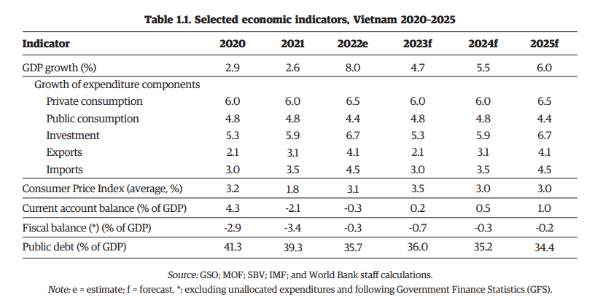

# Vietnam’s Commercial Vehicle Market

In 2022, the commercial vehicle market in Vietnam achieved a valuation of USD 3.07 billion, and it is anticipated to reach USD 5.84 billion by 2030, exhibiting a compound annual growth rate (CAGR) of 8.37% over the forecast period spanning from 2023 to 2030. This market has undergone substantial growth and transformation recently, owing to Vietnam's status as one of Southeast Asia's fastest-growing economies. The surge in industrialization and urbanization has been a significant driving force behind the increasing demand for commercial vehicles in the region. Furthermore, the expansion of the e-commerce and logistics sectors, fueled by a burgeoning middle class and evolving consumer behaviour, has amplified the need for efficient and dependable transportation solutions. Additionally, government investments in infrastructure development and transportation networks have created opportunities for commercial vehicle manufacturers and suppliers to meet the escalating demand.

Innovation has played a pivotal role in shaping Vietnam's commercial vehicle market. Heightened environmental awareness has spurred a notable shift towards adopting greener and more sustainable transportation options. Electric commercial vehicles (ECVs) have gained traction, propelled by advancements in battery technology and government support through incentives and policies promoting electric mobility. Simultaneously, the market has witnessed innovations in connectivity and telematics solutions, enhancing fleet management and operational efficiency. Digital platforms and online sales channels have simplified access to commercial vehicles, streamlining the purchasing process for businesses.

For instance, in 2023, the Toyota Vellfire Executive Lounge has introduced advanced technology and telematics features, including a sophisticated infotainment system with touchscreen controls, smartphone integration, and advanced driver assistance systems. Telematics capabilities enable remote vehicle monitoring and connectivity for an enhanced driving experience.

**Key Trends Shaping the Vietnam Commercial Vehicle Market**

**Rise in Demand for Electric Commercial Vehicles (ECVs)**: The Vietnam commercial vehicle market is poised for growth, primarily driven by increasing demand for ECVs. ECVs offer reduced carbon emissions, lower operational costs, and improved energy efficiency, making them an appealing choice for fleet owners and logistics companies. Government initiatives supporting electric mobility, including subsidies, tax incentives, and infrastructure development, further propel the market's expansion. Advancements in battery technology and charging infrastructure are overcoming barriers to widespread ECV adoption.

**Growing Demand for Used Commercial Vehicles:** There is a notable surge in demand for used commercial vehicles in Vietnam. This trend is driven by cost-conscious businesses, particularly small and medium enterprises, seeking to expand their fleets or replace vehicles within budget constraints. The availability of used commercial vehicles widens the range of options for buyers, allowing them to choose based on their specific operational needs. The growth of the e-commerce and logistics sectors has also fueled demand for reliable transportation, boosting the used commercial vehicle market. Additionally, buying used vehicles promotes sustainability by extending vehicle lifespans and reducing waste.

**Advancement in Technology:** The Vietnam commercial vehicle market has witnessed significant technological advancements in recent years, transforming the industry. Key developments include the adoption of electric and hybrid technologies, enhancing eco-friendly options. The integration of smart and connected technologies, such as telematics and GPS tracking systems, has improved fleet management efficiency and enabled real-time vehicle performance monitoring and logistics operations. Enhanced vehicle safety systems, including advanced driver assistance systems (ADAS), have bolstered road safety and reduced accident rates. Additionally, manufacturers are incorporating lightweight materials and aerodynamic designs to boost fuel efficiency and reduce emissions.

The emergence of autonomous vehicle technology holds the potential to further transform the logistics landscape. These technological innovations are steering the Vietnam commercial vehicle market toward a more sustainable, efficient, and interconnected future. For example, the Toyota Hilux STD, a pickup truck, has seen technological advancements in recent years, featuring advanced safety systems, touchscreen infotainment, smartphone connectivity, and improved fuel efficiency.

**Impact of External Factors**

**Impact of COVID-19**: The COVID-19 pandemic significantly affected the Vietnam commercial vehicle market. Initially, demand plummeted as economic activities slowed, supply chains were disrupted, and uncertainties prevailed. Lockdowns and restrictions further dampened sales and production. However, as the situation improved and restrictions eased, there was a gradual recovery in the market. The pandemic accelerated the adoption of digital technologies, including online vehicle sales and contactless services. Increased focus on last-mile delivery services boosted demand for smaller commercial vehicles.

**Impact of Russia-Ukraine War:** The Vietnam commercial vehicle market experienced limited impact from the Russia-Ukraine conflict due to its geographical distance from the conflict zone. Indirect effects, such as global economic uncertainties and commodity price fluctuations, may have influenced the market. The conflict's influence on international trade dynamics and fuel price fluctuations could have affected operating costs for commercial vehicles. Disruptions in global supply chains may have impacted the availability and cost of vehicle components and raw materials. Nevertheless, the overall impact on the Vietnam commercial vehicle market is expected to be relatively modest compared to regions closer to the conflict.

**Challenges of the market**

The growth and progress of the Vietnam commercial vehicles market are impeded by several challenges. One notable obstacle is the insufficient road infrastructure, particularly in rural areas, which can hinder the effective and dependable operation of commercial vehicles. Enhancing road networks and transportation routes is vital for realizing the market's complete potential. Furthermore, the industry grapples with issues concerning fuel efficiency and environmental impact, given that commercial vehicles are significant contributors to air pollution and greenhouse gas emissions. Promoting the adoption of cleaner and more fuel-efficient vehicles, as well as developing the necessary infrastructure like electric vehicle charging stations, represents a crucial challenge for the sector.

**Key Players and Outlook**

The Vietnam commercial vehicle market features a competitive landscape, with key players competing for market share. Established international manufacturers like Volvo, Toyota, Ford, and Isuzu leverage their brand reputation and advanced technologies to cater to diverse customer demands. Domestic companies like VinFast and Thaco have also made significant progress by offering localized solutions and competitive pricing. The market's outlook remains promising, driven by economic growth, urbanization, and the e-commerce boom. Players that can adapt and innovate are well-positioned to capitalize on the market's growth potential. For instance, Vietnam has been identified as a pivotal market for Ford Motor Company's growth and advancement, alongside Thailand, South Africa, and Australia.

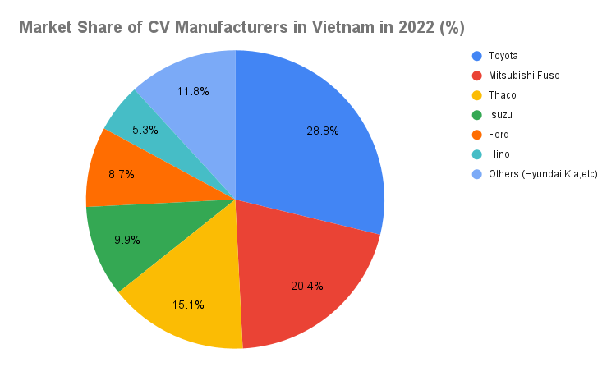

## 

**Vietnam Automobile Manufacturers' Association (VAMA)**

VAMA is a non-governmental organization that represents most of the automobile manufacturers in Vietnam. VAMA members include:

Besides VAMA member units, the Vietnamese auto market also includes other automakers such as

* Volvo
* Audi
* Jaguar Land Rover
* Nissan
* Subaru
* Volkswagen

**Changes in government regulations and policies related to the commercial vehicle market in Vietnam**

The Vietnamese government has in recent years introduced several regulations and policies to support the growth of the commercial vehicle (CV) market and encourage the adoption of cleaner and safer vehicles. These regulations include:

1. **Decree 116/2017/ND-CP**: Enacted in 2018, this decree outlines new rules for the production, assembly, import, and registration of commercial vehicles in Vietnam. It places emphasis on vehicle safety, emissions, and fuel efficiency. Notably, it stipulates that only companies (not individuals) can be considered for a business license to import automobiles. These companies must also have facilities for vehicle warranty and maintenance, either owned or leased. Additionally, auto importers must have documents proving their authorization to recall imported cars on behalf of foreign manufacturers and assemblers. This stringent requirement may lead to a decrease in the number of eligible importers but could benefit consumers by ensuring more reputable and experienced companies enter the market.

2. **Decree No. 17/2020/ND-CP**: Issued on February 5, 2020, this decree amends Decree No. 116/2017/ND-CP and addresses business requirements for manufacturing, assembly, and imports of automobiles, as well as automobile warranty and maintenance services. The amendment includes provisions related to the suspension and revocation of import business licenses for enterprises that import automobiles with navigation software violating Vietnam's sovereignty. It also revises the quality evaluation criteria for imported unused automobiles, focusing on technical safety and environmental protection testing and inspection results.

Exceptions to these regulations are made for national security, temporary imports by entities receiving incentives or exemptions, gifts or personal belongings, and foreign assistance**.**

**Truck Market**

According to the latest Technavio report, the truck market in Vietnam is poised to expand by 41,610 units at a compound annual growth rate (CAGR) of 7.43% from 2021 to 2026. This report delves into truck market segmentation in Vietnam, considering factors such as type (domestic and imported) and tonnage (less than 10 T and more than 10 T).

**Type-**

In terms of type, substantial growth is anticipated in the domestic segment throughout the forecast period. This segment pertains to the sale of trucks that are locally manufactured within Vietnam. Trucks produced within the country constitute more than 60% of the total truck sales in Vietnam. Similar to several other nations, Vietnam has harnessed the advantages of lower manufacturing costs to maintain competitiveness. Currently, the nation is actively exploring opportunities for enhancing supply chain efficiency to remain competitive on the global stage. Consequently, these factors collectively support the assembly and production of trucks within Vietnam.

**Tonnage-**

Regarding tonnage, significant market growth is expected in the category of trucks weighing less than 10 tons during the forecast period. This category encompasses various types of light-duty trucks primarily employed for both intra-city and inter-city transportation. Light-duty trucks play a pivotal role in the timely delivery of time-sensitive and high-value goods, as well as support services. They are particularly favoured in congested urban areas and have gained substantial traction in Vietnam. The increasing issue of traffic congestion is driving the preference for light-duty trucks over medium and heavy-duty counterparts for transporting goods within urban areas in Vietnam.

Notably, significant growth is anticipated in the domestic segment of the truck market during the forecast period. Key players in the truck market include AB Volvo, Beijing Automotive Group Co. Ltd., Daimler AG, Ford Motor Co., General Motors Co., Nissan Motor Co. Ltd., Scania AB, Stellantis NV, Toyota Motor Corp., and UD Trucks Corp.

The truck market in Vietnam is expected to benefit from the increasing pace of industrialization and urbanization, as well as the rapid expansion of the construction sector. Nevertheless, challenges such as the high manufacturing costs of trucks, a shortage of skilled truck operators, and stringent emissions standards for trucks may hinder the growth of companies in this market. To capitalize on these opportunities, companies should focus on the potential for growth in rapidly developing segments while maintaining their positions in slower-growing areas.

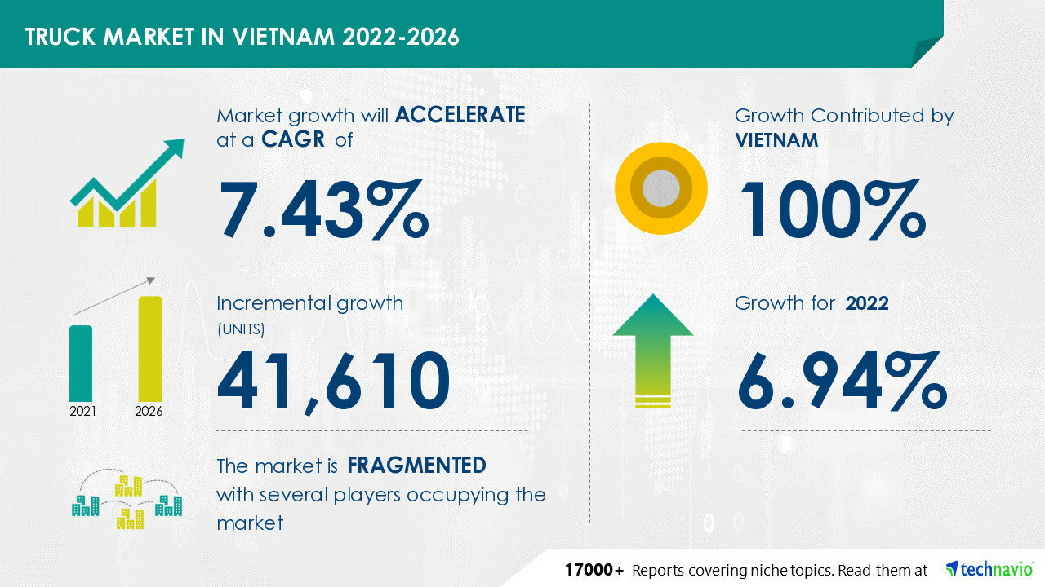

**Buses Market**

- The Buses market is forecasted to achieve a revenue of US$424.00 million in 2023.

- Revenue is predicted to exhibit an annual growth rate (CAGR 2023-2027) of 5.44%, resulting in an estimated market size of US$524.10 million by 2027.

- The Buses market is expected to encompass approximately 16.62 million users by 2027.

- User penetration is anticipated to be 16.9% in 2023 and is projected to decrease slightly to 16.4% by 2027.

- The average revenue generated per user (ARPU) is estimated to be US$25.40.

- Approximately 41% of the total revenue in the Buses market is set to be generated through online sales by 2027.

- In a global context, the majority of revenue will originate from China, amounting to US$4,807 million in 2023.

*YoY change in the Revenue in the Buses Market (Vietnam)*

**Import & Export**

The projected trend for Vietnam's bus imports indicates a gradual decline, averaging a 2.3% decrease per year, moving from $24 million in 2021 to $21 million in 2026. Over the period since 2005, the annual decrease has averaged 2.5%.

Conversely, Vietnam's bus exports are expected to experience an average annual increase of 2.5%, climbing from $1.7 million in 2021 to nearly $2 million in 2026. Notably, the country's exports have displayed substantial growth, averaging 34.1% per year since 2005. China, Germany, and Poland stand out as the primary importers of Vietnamese buses.

# Vietnam Electric Vehicle Market

Vietnam is experiencing rapid economic growth in Southeast Asia, and the government is dedicated to establishing the country as a leader in eco-friendly transportation. As part of this commitment, the government has set ambitious goals for the widespread adoption of electric vehicles (EVs). By 2030, their target is for EVs to make up 10% of all new vehicle sales in Vietnam.

**Vietnam’s Current EV Market**

Motorbikes are the dominant mode of transportation in Vietnam, far outnumbering passenger vehicles. In fact, in 2020, the ratio of motorbikes to cars was an astonishing 30 to 1, with only 5.7% car ownership, significantly lower than in other Asian markets. However, this rate is expected to rise due to the expanding middle class and the growing popularity of ride-sharing services. The International Trade Administration predicts that car ownership will reach 9% by 2025 and 30% by 2030.

The EV market in Vietnam is in its early stages but holds significant growth potential. Electric two-wheelers accounted for 10% of the two-wheeler market in 2021, with nearly 1.8 million electric motorcycles and scooters in use. Vietnam ranks second globally in two-wheeler electrification, following China. Local companies like VinFast and Pega dominate the electric two-wheeler market.

In the electric four-wheeler segment, there has been a substantial increase in production, assembly, and import of electric cars as of August 2022, compared to 2019. VinFast is a leader among domestic companies, while foreign companies are also entering the market with government support. The adoption of EVs holds the promise of reducing greenhouse gas emissions in the transportation sector, with a strong emphasis on clean and renewable energy sources.

Electric buses are also in demand, driven by government policies promoting emissions-free public transportation. Factors like rapid urbanization, fluctuating oil prices, and decreasing battery costs further encourage the adoption of electric buses. Although the electric bus market is growing, it is still constrained by the higher initial cost of electric buses compared to traditional ones.

**Government policies and Incentives**

Vietnam lacks explicit policy frameworks and incentives specifically tailored to the electric vehicle (EV) industry. Instead, the government is advancing EV adoption as part of its broader sustainable development plan, encompassing sustainable development, green growth, climate change, and environmental protection laws. The policy framework addressing EVs and their charging infrastructure is in its early stages and includes:

1. Resolution *55/NQ/TW*, issued on February 11, 2020, which marks the first official national document mandating the promotion of e-mobility and energy storage in alignment with global trends within the National Energy Development Strategy until 2030, with a Vision to 2045.

2. Decision *1095/QĐ-BGTVT* dated June 17, 2021, outlining the development of an environmentally friendly vehicle strategy under the “National Transportation Vehicle Development Strategy”. This strategy is to be executed by the Transport Development and Strategy Institute between 2022 and 2023.

3. The approval of the Paris Agreement in July 2020, with Vietnam committing to reducing greenhouse gas (GHG) emissions by 9% by 2030 in its updated Nationally Determined Contribution (NDC). EV adoption holds great potential for reducing GHG emissions in the transport sector. As part of this plan, in January 2022, Ho Chi Minh City was selected as the first area to conduct studies on the development of e-transport, incorporating e-vehicles in the southern hub.

4. Decision No. *1393/QĐ-TTg* from 2012 regarding the National Green Growth Strategy (NGGS). The Ministry of Planning and Investment is formulating a new NGGS for the period 2021-2030, with considerations for vehicle electrification. Several provincial Green Growth Action Plans also include transportation aspects and electrification targets.

5. Hanoi's Green Growth Strategy, which aims to have e-motorcycles account for 5% of the total motorcycle fleet in Hanoi by 2030.

6. Nha Trang's Green Growth Strategy, which strives to introduce 200 e-buses into circulation by 2025 in Nha Trang.

7. The National Automobile Development Strategy (2021-2050), proposed by the Vietnam Automobile Manufacturers Association (VAMA), aims to stimulate manufacturing, and increase the utilization of e-vehicles. Between 2030 and 2040, there is a significant envisioned growth in the number of electric vehicles, targeting a production capacity of 3.5 million vehicles by 2040.

To further bolster the development of the EV industry in Vietnam, the government has recently issued new decisions, including:

- *Decree 10/2022*, effective from March 1, 2022, which exempts registration fees for Battery Electric Vehicles for the first 3 years and reduces them by 50% for the subsequent 2 years.

- *Law no. 03/2022/QH15*, effective from March 1, 2022, which reduces the excise tax rate for battery electric vehicles to 1-3% for a five-year period starting from March 1, 2022.

**Incentives on the Supply Side for EVs**

The Vietnamese government encourages investments in EV and battery production, albeit with limited policy support. For example, proposals for tax incentives on imported electric cars have been rejected by Vietnam's Ministry of Finance due to concerns about potential adverse effects on local manufacturers. The government has also refrained from contributing to infrastructure development or research and development efforts.

While Vietnam has introduced an "environmental tax" on fossil fuel users, its impact has been modest. More effectively, the National Assembly has reduced excise taxes on electric cars, leading to reduced production costs and greater affordability for electric four-wheelers.

**Incentives on the Demand Side for EVs**

Several policies have been designed to promote the adoption of electric four-wheelers in Vietnam, although there are no corresponding measures to popularize electric two-wheelers. Incentives for electric four-wheelers include:

Registration fee reduction: The Prime Minister has issued a Decree to lower registration fees for electric vehicles. Over a three-year period, fees for battery powered EVs will be phased out, and until then, they will be half as expensive as registration fees for petrol and diesel cars with the same seating capacity.

Special consumption tax: Prior to 2022, imported EVs were subject to special consumption taxes ranging from 15% to 70%. However, starting from March 1, 2022, excise tax rates for EVs were reduced by up to 12%.

Public transportation incentives: Decision 13/2015/QD-TTg utilizes incentives such as favourable loans, import duty exemptions, and subsidies to stimulate the development of public electric and natural gas buses.

Given the current global trend toward EVs, the nascent development of the battery industry and charging infrastructure, the pioneering efforts of key private manufacturers, and the Vietnamese government's commitment to promoting low-carbon transport, the EV market in Vietnam holds promise. However, it still requires robust and explicit government support encompassing policies, tax incentives, price subsidies, standards, and technical regulations to further foster EV development.

**Challenges in Vietnam's EV Market**

While the potential for growth in Vietnam's EV market is evident, it has encountered some obstacles along the way.

**Inadequate Government Regulations and Policies**

Vietnam's EV-related policies have proven to be insufficient and ineffective, with policymakers struggling to create regulations that can effectively attract more investment. Additionally, attempts by the government to discourage the use of internal combustion engine (ICE) vehicles through environmental taxes have not produced significant improvements, possibly due to their limited impact on consumer behaviour. The absence of effective incentives or price subsidies has also hindered the adoption of EVs. Furthermore, the lack of specific regulations for battery production and charging infrastructure installation presents further challenges to the development of EVs.

**Limited Charging Infrastructure**

Many of Vietnam's challenges in adopting EVs are linked to the availability of battery and charging infrastructure. The scarcity of rapid-charging stations is a major hindrance, despite efforts by companies like VinFast to install quick-charge stations for electric motorbikes, which have seen limited success. Attempts to promote battery swapping face their own set of challenges, including feasibility primarily for two- and three-wheelers, the need for expensive infrastructure establishment, and compatibility issues between brand-specific systems.

**Lack of Investment and Support**

While Vietnam's electric two-wheeler industry possesses significant production capacity driven by market demand, the electric four-wheeler market lags due to a lack of investment. Consequently, consumers have very limited choices when it comes to electric four-wheeler options, perpetuating the issue by slowing down market demand, which, in turn, hampers industry growth. This situation is partly a result of Vietnam's reliance on imported spare parts, which increases vehicle production costs. The absence of comprehensive EV-related technical standards exacerbates the problem, as manufacturers may be hesitant to invest in EV production in the absence of a clear regulatory framework.

**Investment Opportunities**

The automotive manufacturing sector is a significant industry in Vietnam, contributing 3% to the country's GDP. Vietnam has undertaken numerous substantial automotive assembly and production initiatives with the goal of not only meeting domestic demand but also accessing the regional market.

Consequently, there are numerous investment prospects available for Vietnamese citizens, enterprises, and governmental bodies in the field of EV production. Some particularly promising investment opportunities include:

1. **Battery Manufacturing**: Vietnam possesses substantial reserves of nickel (3.6 million tons) and lithium (1 million tons). Nevertheless, there is still limited research and technology development for the effective utilization of these minerals.

2. **Public Transportation**: In line with many nations, Vietnam is committed to reducing environmental pollution through substantial investments in electric vehicle fleets for public transportation.

3. **Assembly and Sales Ventures**: The recent EU-Vietnam Free Trade Agreement (EVFTA) enables investors to export products manufactured in Vietnam to international markets.

**Future of Vietnam's EV Market**

Vietnam's electric vehicle (EV) sector is experiencing rapid growth in Southeast Asia, primarily driven by private companies. Despite the prevalent motorbike culture, the country is witnessing an increasing embrace of EVs, particularly in the electric two-wheeler segment, which has gained a substantial market share. Government backing for transitioning to clean energy and achieving emission reduction targets has spurred initiatives aimed at promoting the production, importation, and development of charging infrastructure for EVs.

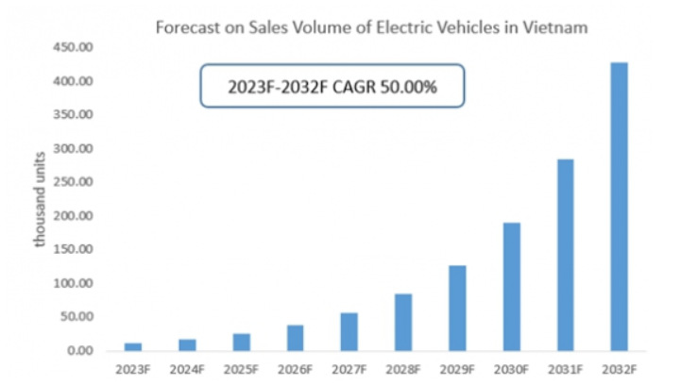

**Vietnam Electric Commercial Vehicle Market**

The Vietnam electric commercial vehicle market is expected to experience significant growth by 2028, with a double-digit compound annual growth rate (CAGR). This growth is driven by the increasing demand for fuel-efficient and environmentally friendly vehicles, particularly electric trucks in the logistics industry. The market is segmented based on different propulsion technologies, including Battery Electric Vehicles (BEV), Hybrid Electric Vehicles (HEV), Plug-in Hybrid Electric Vehicles (PHEV), and Fuel Cell Electric Vehicles (FCEV). In 2022, BEVs held the largest market share, and they are projected to continue growing at the highest CAGR in the foreseeable future.

Although there may be a temporary dip in vehicle sales in 2023 due to COVID-19 lockdowns, the market is expected to rebound as there is a growing emphasis on reducing greenhouse gas emissions, and the government is offering incentives for electric vehicle purchases.

Furthermore, Mitsubishi Motors is collaborating with the Vietnam Industry Agency to explore ways to promote the efficient use of electric vehicles and develop public policies that support the rapid adoption of sustainable automotive technology. In terms of range, the market is divided into different categories, with the "500 Miles & Above" range segment expected to grow at the highest CAGR during the forecast period, primarily due to the increasing production and sale of electric buses.

Key players in the Vietnam electric commercial vehicle market include Volvo, Daimler, Tesla, Proterra, Nissan, BYD, Honda, Hyundai, VDL and ABB. These companies are actively developing new products and advanced technologies to remain competitive in the market, and many are engaging in mergers and collaborations as part of their strategic efforts to thrive in a competitive market landscape.

# Vietnam Commercial Vehicle Lubricants Market

In 2021, the Vietnam Commercial Vehicles Lubricants Market recorded a volume of 45.11 million litres, and it is estimated to exhibit a Compound Annual Growth Rate (CAGR) of 3.61% to attain 53.85 million litres by 2026.

**Largest segment by Product type - Engine Oils**: Engine oils lead the market in terms of product type, primarily due to their higher volume requirements and shorter replacement intervals in comparison to other lubricants used in various vehicle categories.

**Fastest segment by Product Type - Hydraulic Fluids**: The expected resurgence in commercial vehicle sales and utilization rates in Vietnam starting from 2021 is anticipated to fuel the demand for hydraulic fluids throughout the forecast period.

In Vietnam, commercial vehicles (CVs) constituted the second-largest sector in terms of lubricant usage. Between 2015 and 2019, the consumption of lubricants in the CV category saw significant growth, achieving a Compound Annual Growth Rate (CAGR) of over 10%. This growth was primarily propelled by the increasing volume of freight transportation within the country.

However, in 2020, due to the impact of COVID-19 on freight transport, lubricant consumption for commercial vehicles experienced a decline of 7.11%. Engine oil made up approximately 69% of CV lubricant consumption, and there was a notable drop of more than 18% in the use of hydraulic fluids within the CV segment in 2020.

Looking ahead from 2021 to 2026, the hydraulic fluid sector is expected to be the fastest-growing segment, with an estimated CAGR of 5.61%. This growth is anticipated to be driven by the recovery in the production and sales of commercial vehicles, leading to increased consumption of transmission oils during the forecast period.

Vietnam Commercial Vehicles Lubricants Market Leaders:

* BP Plc (Castrol)
* Mekong Petrochemical JSC
* Petrolimex (PLX)
* Royal Dutch Shell Plc
* TotalEnergies

**Vietnam Commercial Vehicles Lubricants Market News**

**January 2022**: ExxonMobil Corporation underwent restructuring, effective from April 1, organizing its operations into three distinct business lines: ExxonMobil Upstream Company, ExxonMobil Product Solutions, and ExxonMobil Low Carbon Solutions.

**March 2021**: Castrol introduced Castrol ON, an e-fluid series encompassing e-gear oils, e-coolants, and e-greases, as a new addition to its product lineup. This range is specifically designed for electric vehicles.

**March 2021**: Hyundai Motor Company and Royal Dutch Shell PLC announced a five-year global business collaboration agreement with a renewed focus on clean energy and carbon reduction. This partnership aims to support Hyundai's evolution into a Smart Mobility Solution Provider.

# Volvo in Vietnam

Volvo Cars made its debut in the Vietnamese market back in 2007 when it introduced the Volvo S80 luxury sedan. Since then, the company has positioned itself as a prominent player in the premium car segment, emphasizing safety, technology, and design. In 2018, Volvo Cars unveiled plans to commence local assembly of some of its vehicles in Vietnam, a strategic move aimed at reducing costs and offering more competitive pricing to its customer base.

**Diverse Car Lineup:**

Volvo Cars boasts a diverse range of vehicles in Vietnam, encompassing sedans, SUVs, and wagons. Let's delve into some of the most sought-after models.

**Volvo XC90:**

The Volvo XC90 represents a luxurious seven-seater SUV that seamlessly combines power, comfort, and safety within an elegant package. Equipped with an array of advanced features, including a 9-inch touchscreen display, a premium 19-speaker Bowers & Wilkins sound system, and a panoramic sunroof, the XC90 leaves no stone unturned in offering a premium driving experience. Furthermore, it incorporates a comprehensive suite of safety technologies, such as adaptive cruise control, blind-spot monitoring, and lane departure warning.

**Volvo S60:**

The Volvo S60 stands out as a stylish and sporty luxury sedan, providing a smooth and comfortable ride. Loaded with advanced amenities like a 9-inch touchscreen display, a high-quality Harman Kardon sound system, and a panoramic sunroof, the S60 delivers both style and substance. Safety is a paramount focus, with features like City Safety designed to prevent or mitigate collisions with other vehicles, pedestrians, and cyclists.

**Volvo V90 Cross Country:**

The Volvo V90 Cross Country is a robust and adaptable wagon perfectly suited for navigating Vietnam's diverse road conditions. This model comes equipped with an array of advanced features, including a 9-inch touchscreen display, an impressive 19-speaker Bowers & Wilkins sound system, and a panoramic sunroof. Safety is paramount yet again, with the inclusion of Pilot Assist, aiding in steering, acceleration, and braking on well-marked roads at speeds of up to 130 km/h.

This encapsulates the essence of Volvo Cars' presence in Vietnam, showcasing its commitment to delivering a range of premium vehicles catering to various preferences and needs in the Vietnamese automotive market.

Volvo Cars distinguishes itself from competitors through a range of factors:

**Safety:** Safety has consistently been a paramount concern for Volvo Cars, and their vehicles are renowned for incorporating cutting-edge safety technologies like City Safety, Lane Keeping Aid, and Pilot Assist.

**Design:** Volvo Cars are celebrated for their stylish and sophisticated design, harmonizing Scandinavian minimalism with opulent accents.

**Sustainability:** Volvo Cars is resolutely dedicated to diminishing its environmental impact and has established an objective to achieve climate neutrality by 2040.

**Volvo Commercial Vehicles (Vietnam)**

**Trucks**

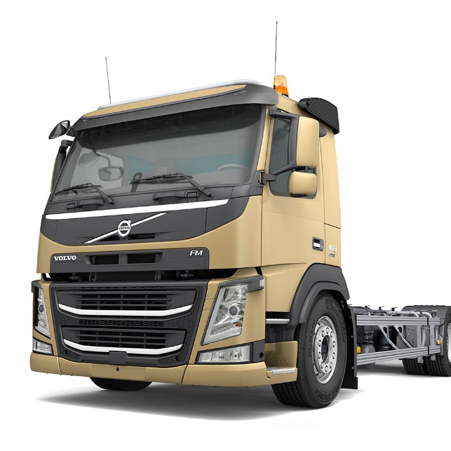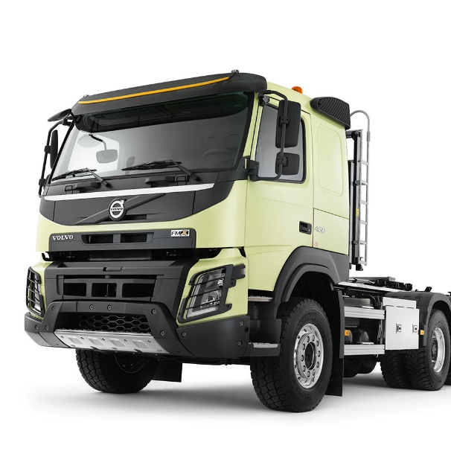

Volvo FMX

Volvo FM

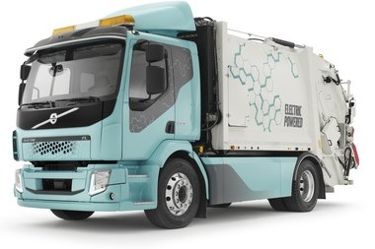

Volvo FL Electric

**Buses**

Volvo B11R

Volvo 9900

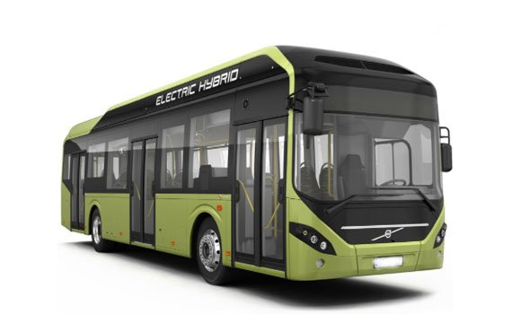

Volvo 7900 Electric

Volvo 9400XL

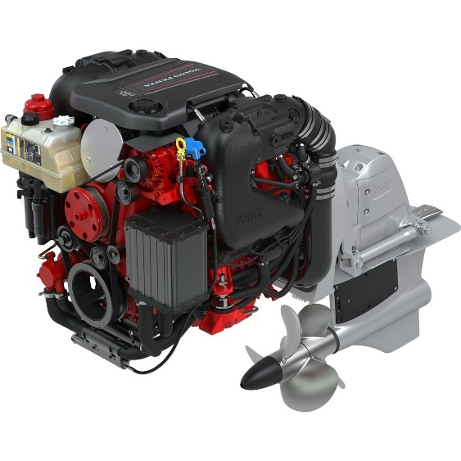**Volvo Penta (Marine Engines)**

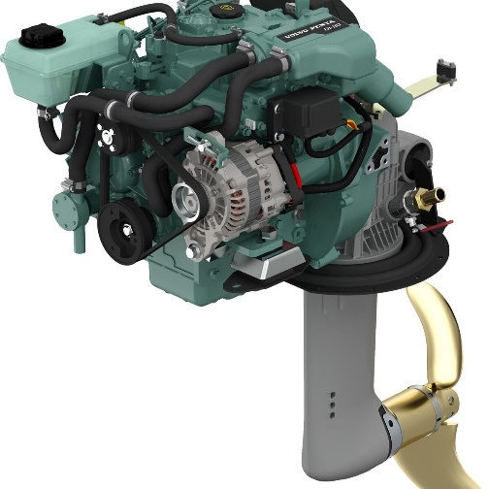

V6 FWD TCC

D1

**Construction Equipment**

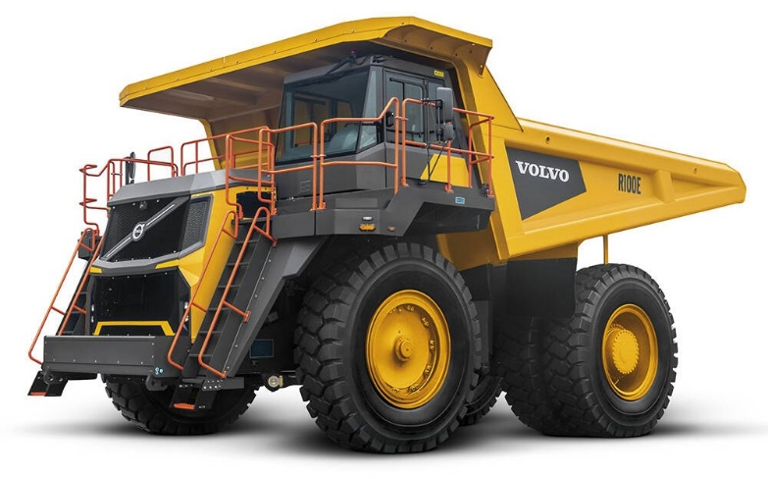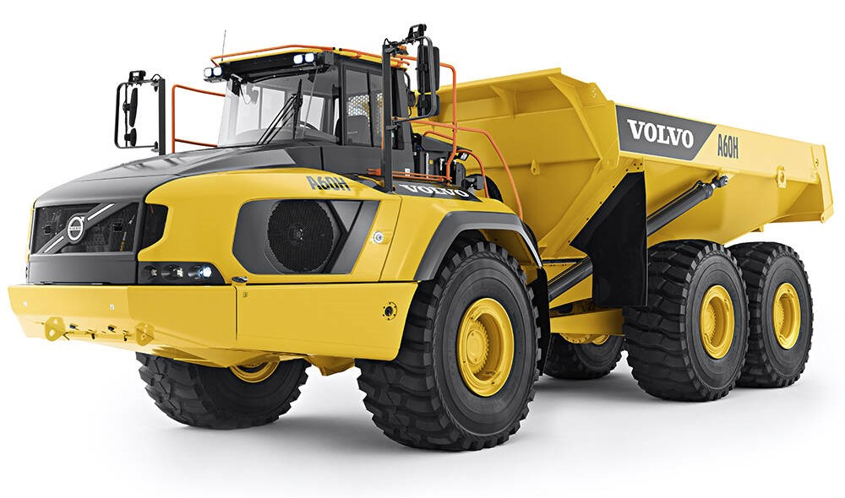

Rigid Haulers (R100E)

Articulated Haulers (A60H)

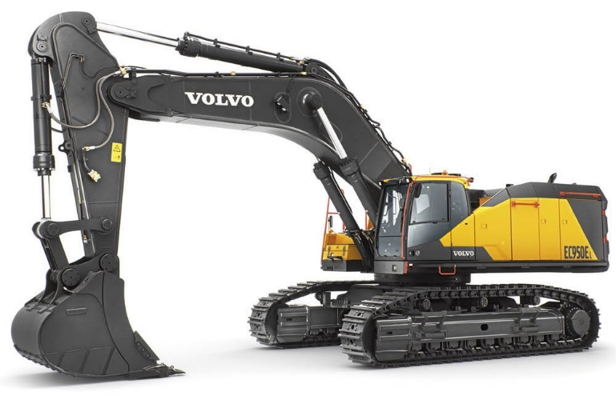

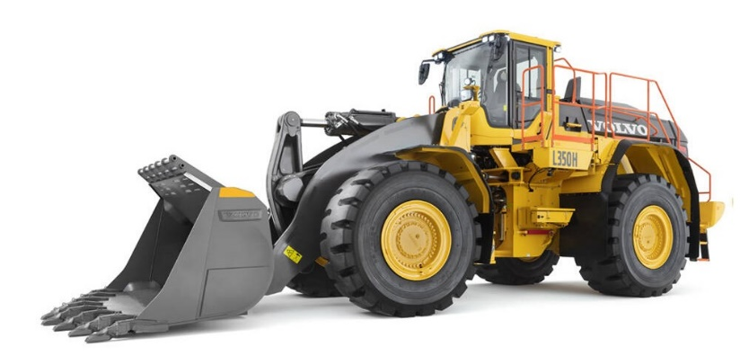

Wheel Loaders (L350H)

Excavator (EC950E)

**Distribution Network**

Volvo has several distributors in Vietnam, including:

* **T&C Machinery and Parts**: The exclusive distributor of Volvo construction equipment in Vietnam for the past seven years. T&C Machinery and Parts is a subsidiary of T&C Group.
* **T&C Trucks**: The authorized distributor of Volvo trucks in Vietnam.
* **Volvo Penta Vietnam TTTT**: The official dealer in Vietnam for Volvo Penta engines and parts.
* **Euro Auto JSC**: The authorized importer and distributor of Volvo cars in Vietnam.

Savico is the largest vehicle distributor in Vietnam and distributes Volvo cars.

**Volvo Trucks Imports to Vietnam**

* As per Volza’s Vietnam Import data, Volvo truck import shipments in Vietnam stood at 3.6K, imported by 74 Vietnam Importers from 189 Suppliers.
* Vietnam imports most of its Volvo truck from Turkey, Sweden and Germany.
* As per the Volza's Vietnam Volvo truck Buyers & importers directory, there are 74 active Volvo truck Importers in Vietnam Importing from 189 Suppliers.
* T C MACHINERY AND PARTS JOINT STOCK accounted for maximum import market share with 918 shipments followed by JOINT STOCK COMPANY NATIONAL MACHINERY T C with 632 and CONG TY CO PHAN MAY VA PHU TUNG was at the 3rd spot with 512 shipments.

# The forthcoming lineup of Volvo cars in Vietnam

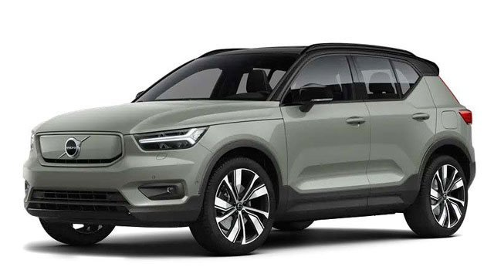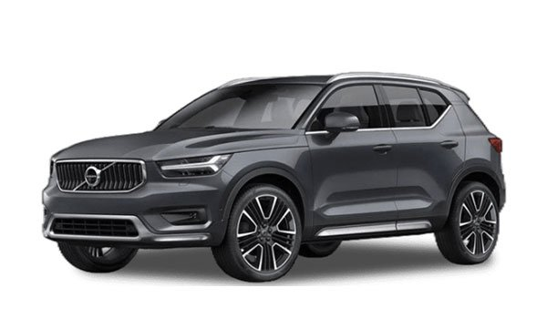

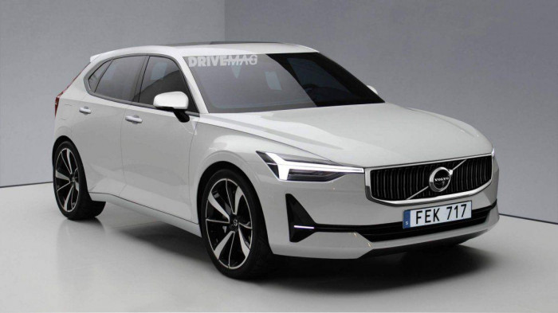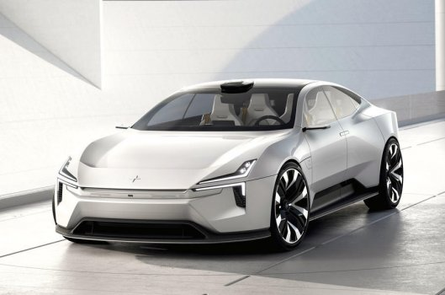

Volvo V40 (2024)

Volvo Polestar 3

Volvo XC90 T5 Momentum (Oct 2023)

Volvo V40 (Oct 2023)

Volvo XC40 P8 Electric (Oct 2023)

# The Modern Vietnamese Consumer

The emergence of the prosperous class is shaping Vietnam's consumer market, leading to evolving demands, shifting priorities, and the embrace of novel goods and services.

Vietnamese households are becoming smaller in size, with approximately 40% of households consisting of one to three members. The primary consequence of this trend is reduced consumption, which has prompted the growth of outsourcing services and the pet food industry.

There is an increasing desire for customization, with a particular focus on female consumers, as well as those from Generation Z and Generation Alpha, who seek more personalized products and services.

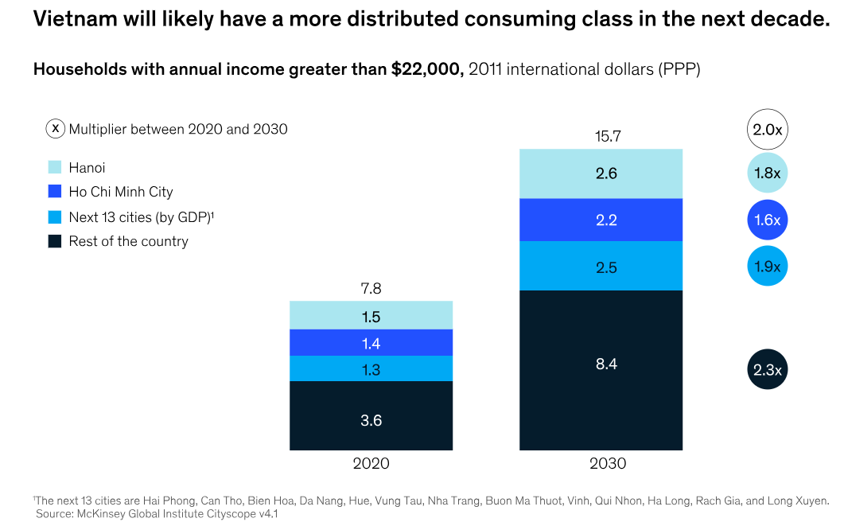

# **Bibliography**

1. ‘Making Public Invest Work For Growth’ report by World Bank (August 2023).[[1]](https://www.worldbank.org/en/news/press-release/2023/08/10/vietnam-s-economic-growth-slows-due-to-global-headwinds-and-internal-constraints#:~:text=The%20report%20shows%20that%20Vietnam's,2024%20and%206.0%25%20in%202025)
2. Briefing, V. (2023, August 8). Vietnam’s Mid-year Economic Report Card Shows Mixed Results. Vietnam Briefing News.[[2]](https://www.vietnam-briefing.com/news/vietnam-economy-h1-2023.html/)
3. MarketResearch.com. (n.d.).[[3]](https://www.marketresearch.com/Market-Xcel-v4265/Vietnam-Commercial-Vehicle-Assessment-Type-34720433/)
4. V. (n.d.). Vietnam Automobile Manufacturers’ Association. Copyright © 2022.[[4]](http://vama.org.vn/en/default.html)
5. New Decree Could Drastically Affect Auto Business in Vietnam - Tilleke &amp; Gibbins. (2021, January 12). Tilleke & Gibbins.[[5]](https://www.tilleke.com/insights/new-decree-could-drastically-affect-auto-business-vietnam/#:~:text=On%20October%2017%2C%202017%2C%20the%20government%20of,took%20immediate%20effect%2C%20companies%20operating%20in%20the)
6. Market Research Reports - Industry Analysis Size & Trends - Technavio. (n.d.). Technavio, https://www.technavio.com/, All Right Reserved 2023.[[6]](https://www.technavio.com/report/truck-market-in-vietnam-industry-analysis)
7. Buses - Vietnam: Statista Market Forecast.[[7]](https://www.statista.com/outlook/mmo/shared-mobility/shared-vehicles/buses/vietnam)
8. Bharadwaj, R. (n.d.). Vietnam’s EV Landscape & Market: An In-Depth Analysis | Bolt.Earth Blog. Bolt Earth.[[8]](https://bolt.earth/blog/ev-landscape-in-vietnam)
9. Vietnam Electric Vehicle Industry. (n.d.). International Trade Administration | Trade.gov.[[9]](https://www.trade.gov/market-intelligence/vietnam-electric-vehicle-industry)
10. Vietnam Commercial Vehicles Lubricants Market ... - Mordor Intelligence.[[10]](https://www.mordorintelligence.com/industry-reports/vietnam-commercial-vehicles-lubricants-market)
11. Volvo Car Prices Vietnam | Volvo New Cars Model 2023 - Ccarprice VNM. (n.d.). CcarPrice.[[11]](https://www.ccarprice.com/vn/volvo-car-prices-in-Vietnam-132#:~:text=Volvo%20Cars%20in%20Vietnam:%20A,safety%2C%20technology%2C%20and%20design)
12. Volvo truck Imports in Vietnam  - Import data with price, buyer, supplier, HSN code. (2023, July 6).[[12]](https://www.volza.com/p/volvo-truck/import/import-in-vietnam/)
13. Delteil, B., Francois, M., Mai, D., & Seong, J. (2021, December 7). The new faces of the Vietnamese consumer. McKinsey & Company.[[13]](https://www.mckinsey.com/featured-insights/future-of-asia/the-new-faces-of-the-vietnamese-consumer)